|  |  |
| --- | --- |
| Course Name | ITD 2343 – Object Oriented Programming with C# |
| Instructor | Mark L. Pranger |
| Student Name | Cristhian Carcamo |
| Due date | 3/27/2025 |
| Grade | <grade earned here> |
| Grading Comments | <instructor comments here> |

**Lab Portion of the Section 3 Exam**

Development:

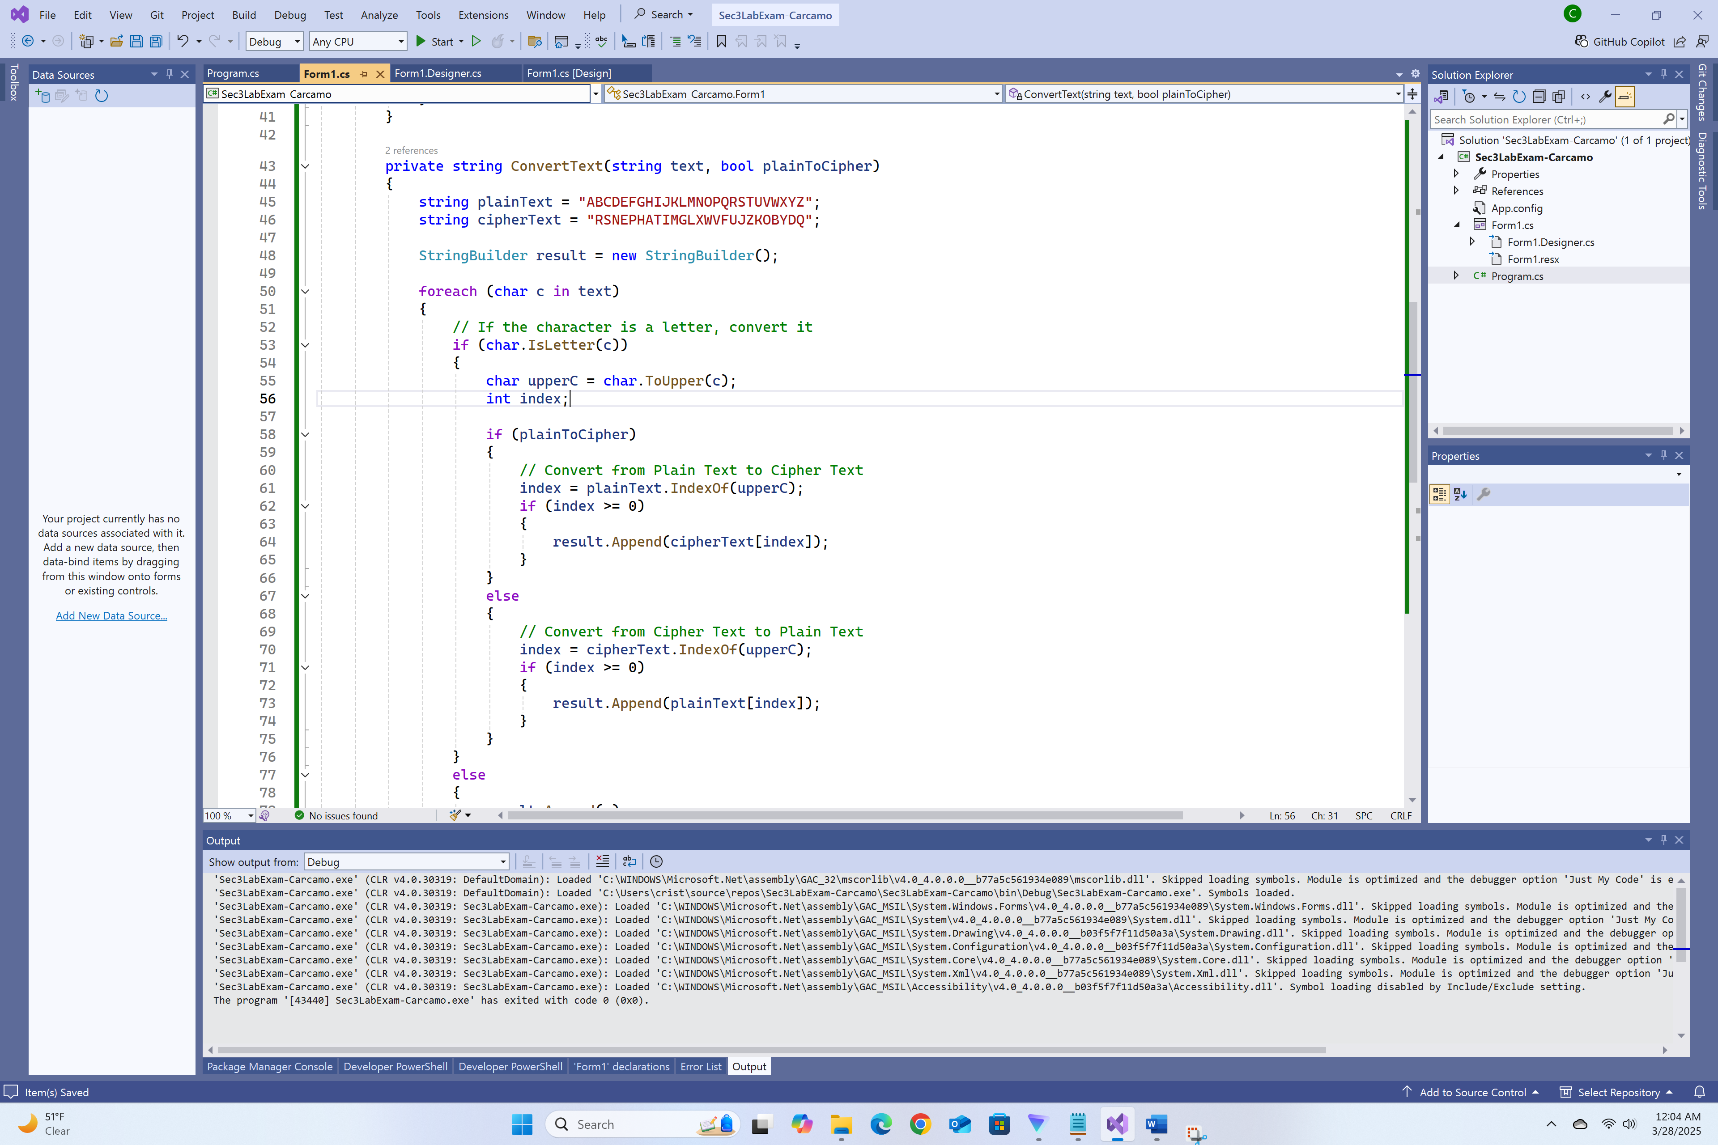

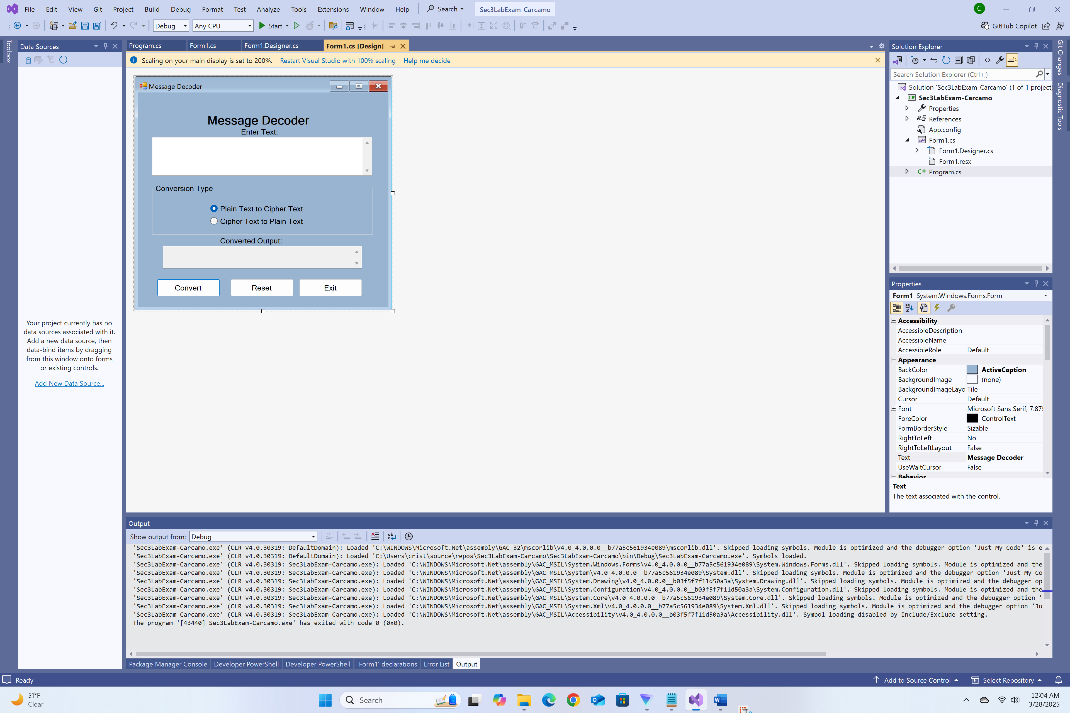

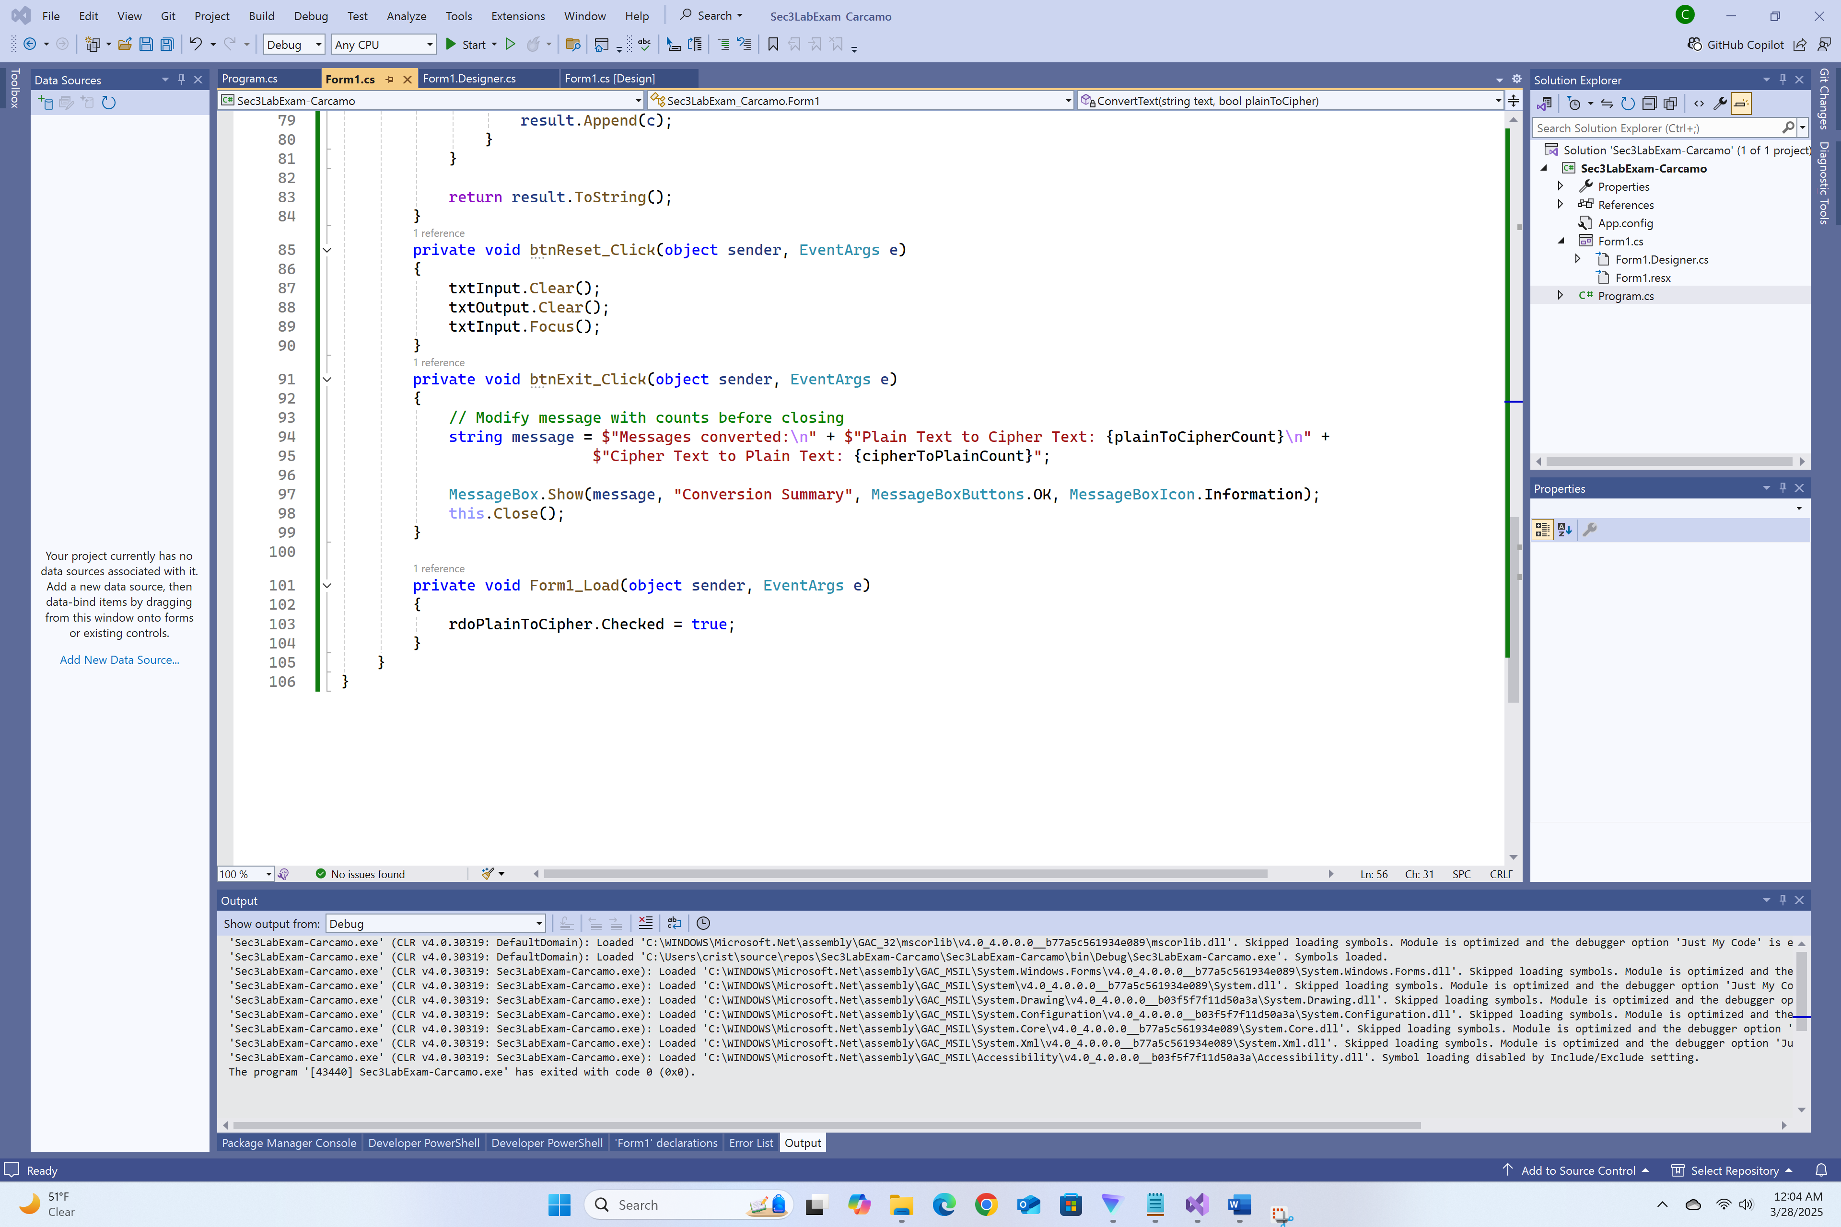

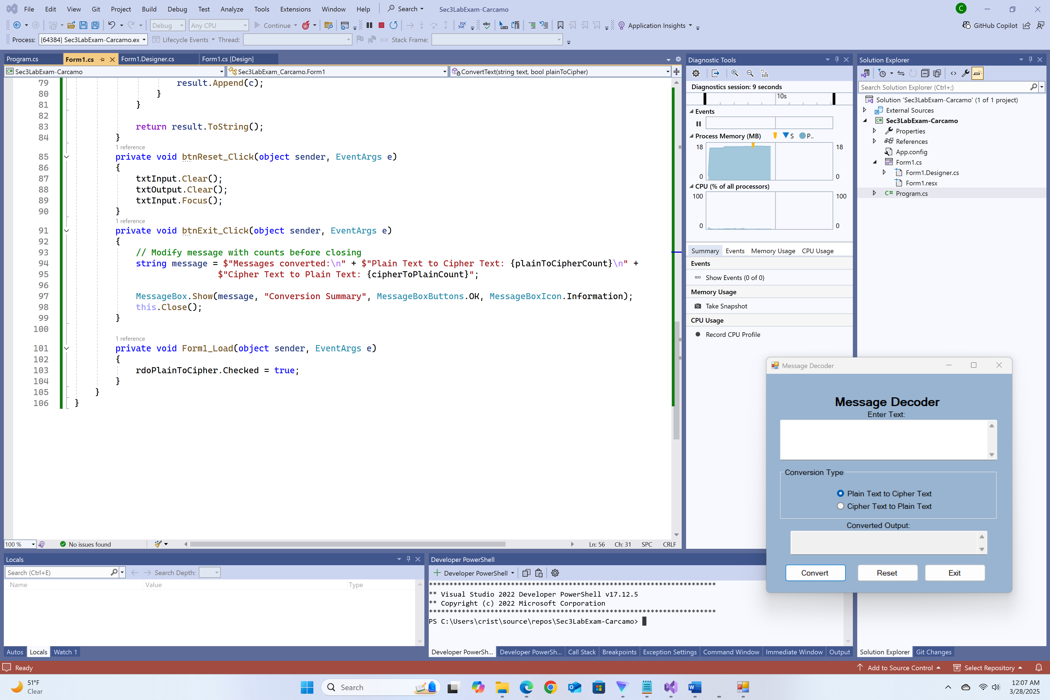

Enter your name and covert it to Cipher Text

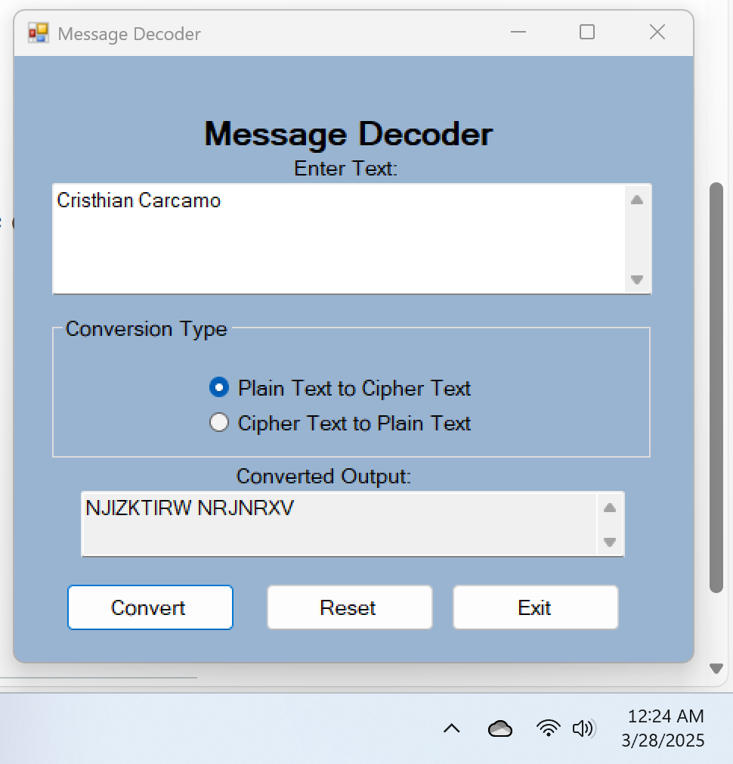

Enter Professor Greg Morris and convert it to Cipher Text

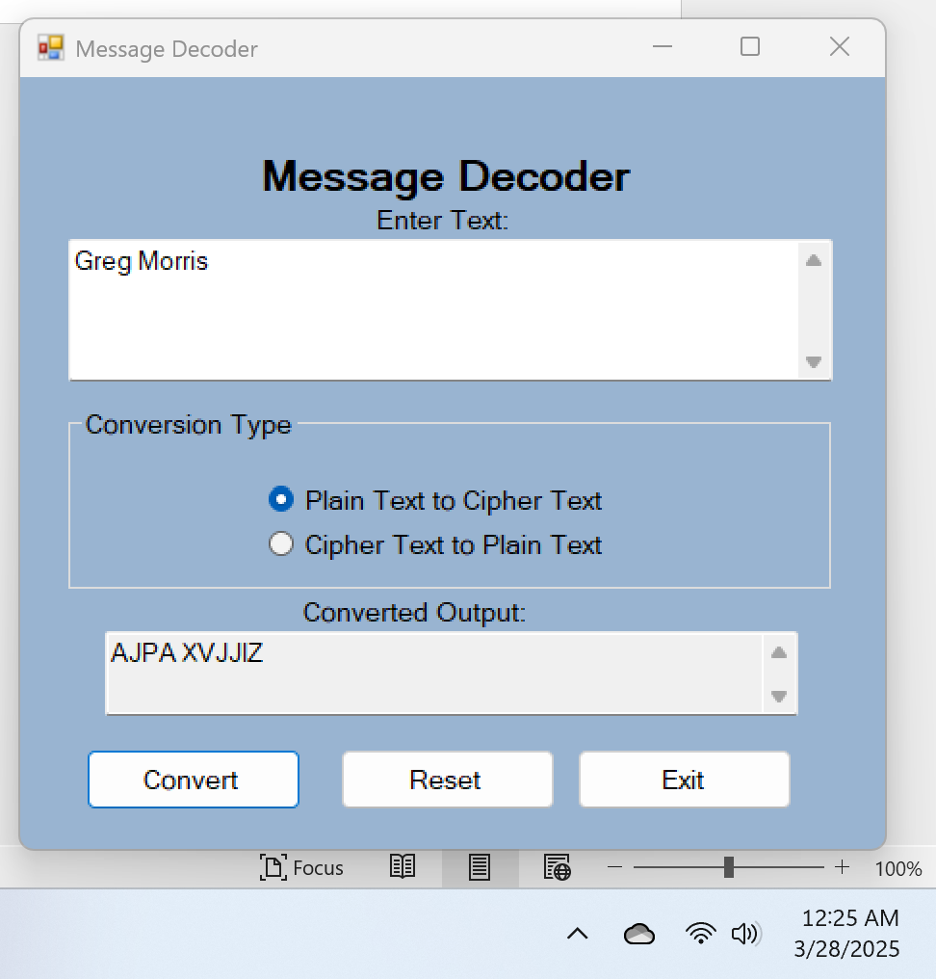

Convert the following phrase to Cipher text:  Four Score and Seven Year ago.

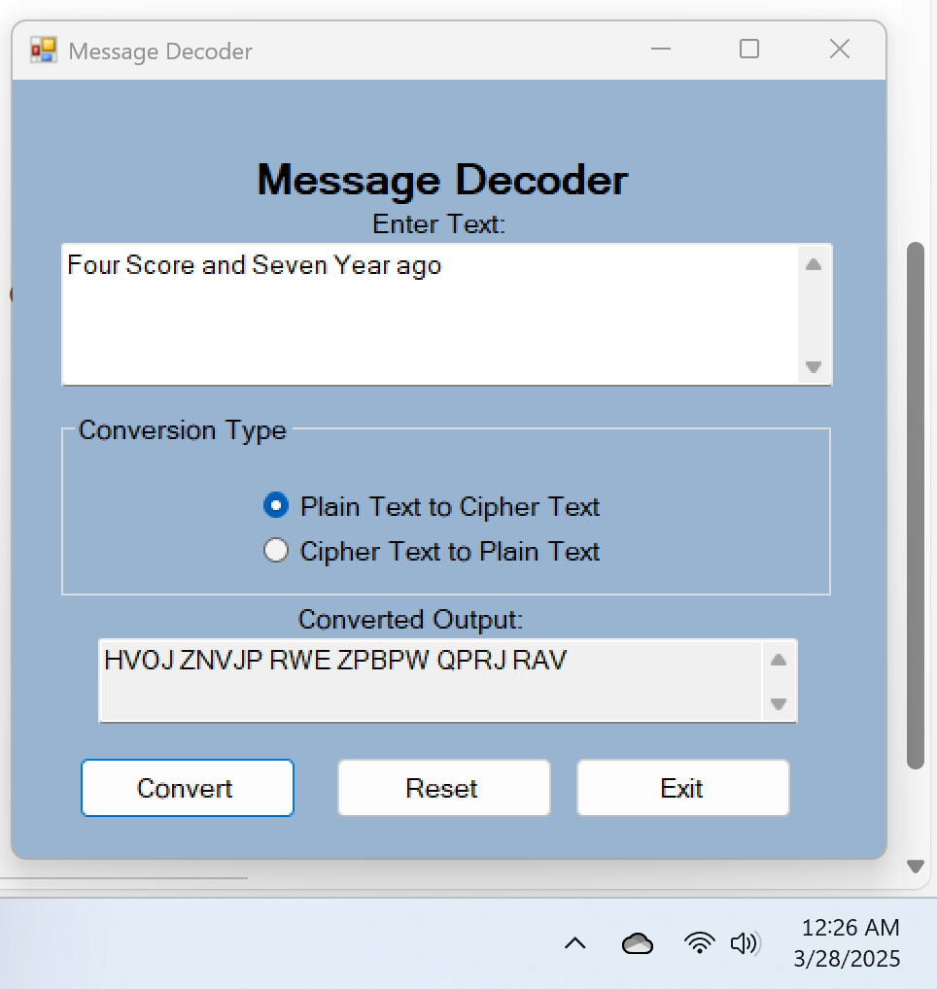

For giggles, use your name as cipher text and covert it back to plain text to see what it says

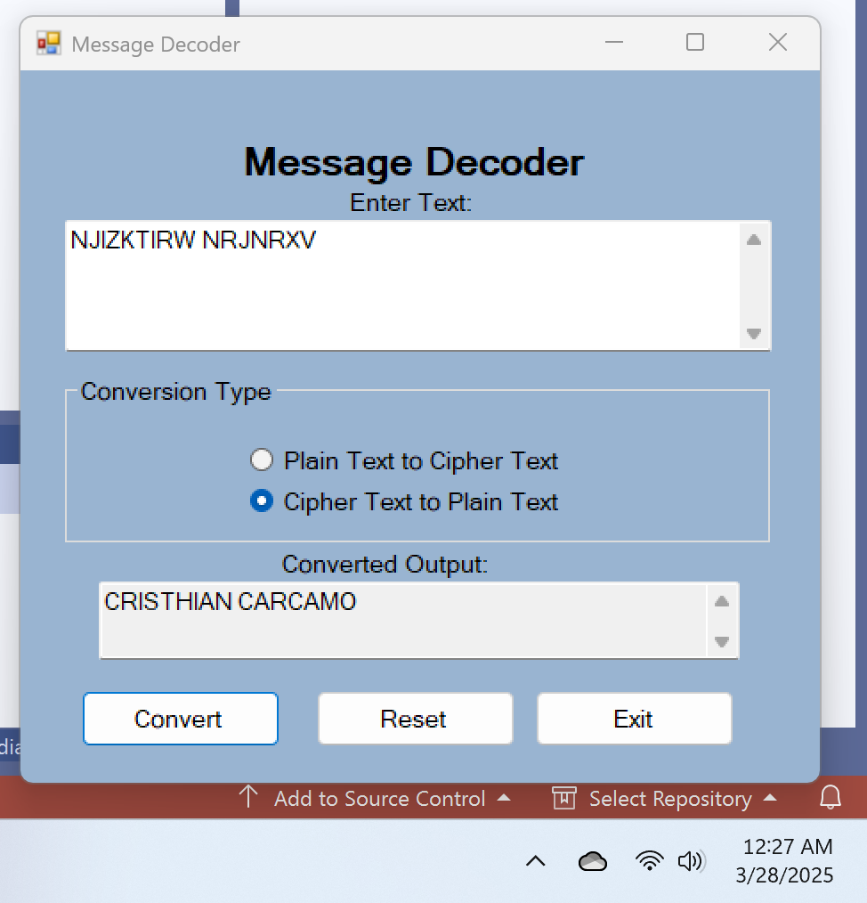

Show the plaintext of the following cipher text phrase: "HfVFo EIcN OFv oI MkX np"

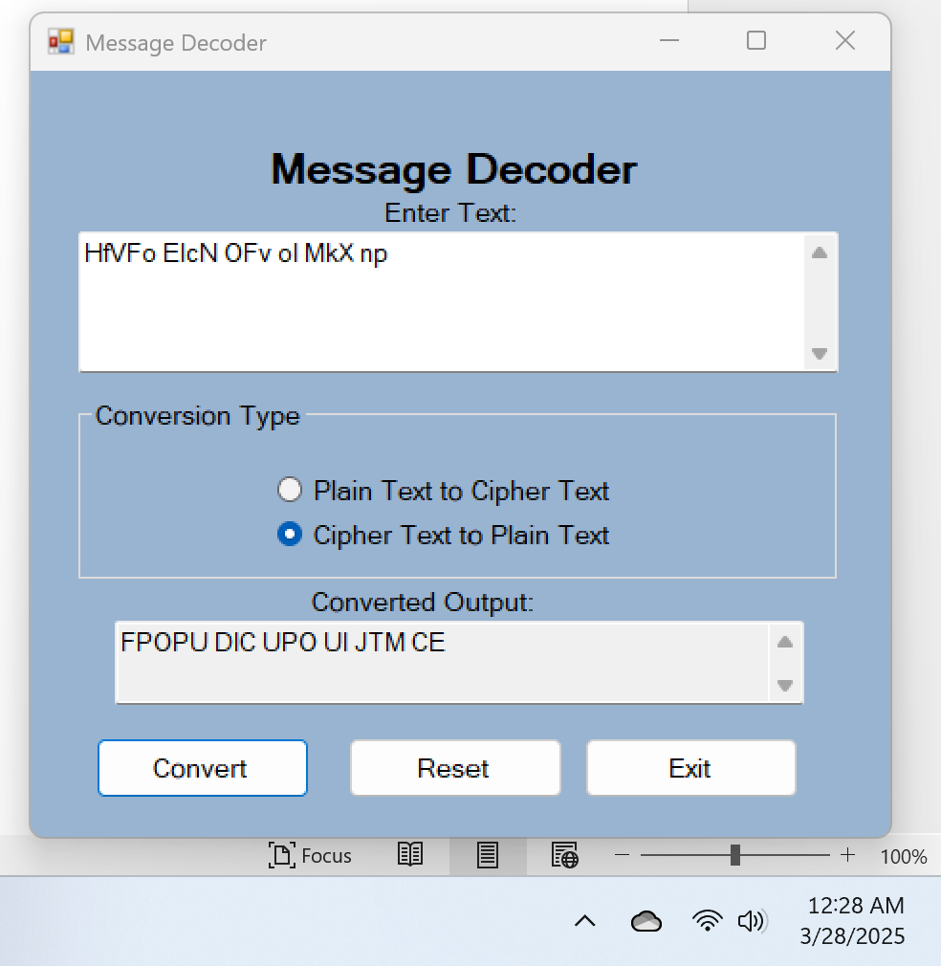

Show the error when you try and convert an empty input to cipher text

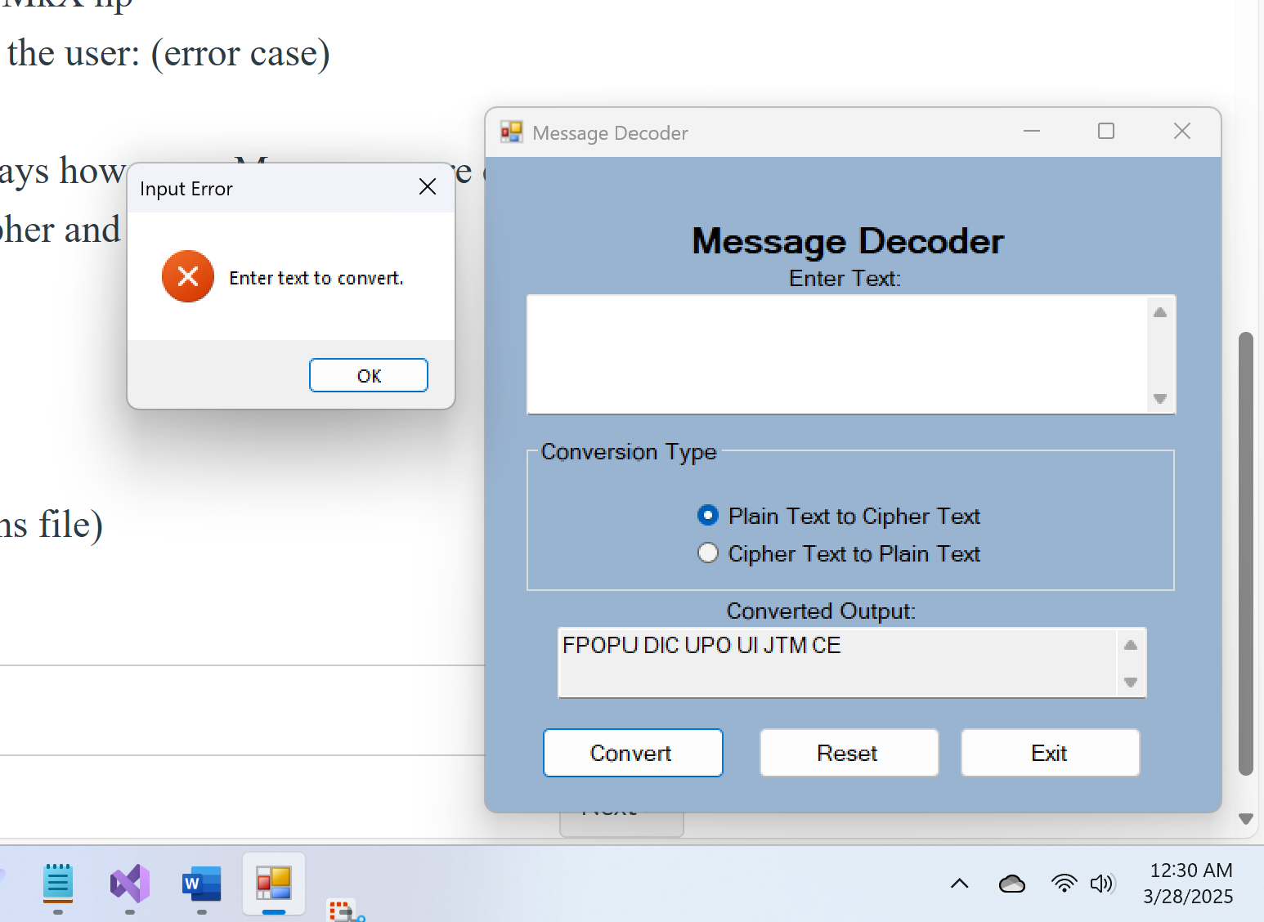

One Screen Shot showing the Message Box when you exit the application that says how many Messages were converted

